**As per Health Information and Quality Authority Guidance on Dose Constraints in Medical Exposures to Ionising Radiation, 20 February 2020,**

“An undertaking shall ensure that dose constraints, as specified or approved by an ethics committee on a case by case basis as part of a proposal for medical or biomedical research, are used in the optimisation of protection and safety for persons. The European Commission Guidance on medical exposures in medical and biomedical research (Radiation Protection 99) and International Commission on Radiological Protection ICRP 103 guidance documents provide useful information for ethics committees when reviewing potential research projects involving the use of ionising radiation. **Ethics committees must consider the radiation dose to the individual and the potential benefit to society.** Each dose category acts as a dose constraint as long as the potential societal benefit is commensurate. For example, a project subjecting individuals to an effective radiation dose of 6 mSv should only be granted ethical approval if there is a moderate societal benefit arising from the exposure such as directly aiding the diagnosis cure or prevention of disease. More information is given in Table 2.”[1]

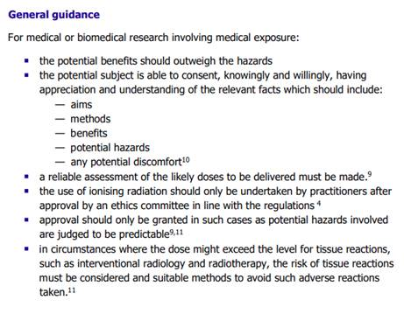

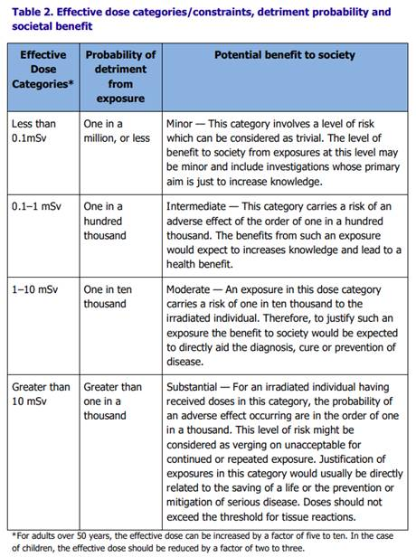

1. Page 7-13